Scrum - Artifacts Workbook

**Definition of Done**

| Definition | Done should include everything we need to do for all items of this increment release, including user acceptance testing. |
| --- | --- |
| Purpose | a well-understood and clearly documented definition of items that must be established to mark a story (or iteration or project) to be complete. Getting a story to a completed state per the definition of done should be the goal of a team and should be used as the basis for planning. |

**Product Backlog**

| Definition | is an ordered list of requirements |
| --- | --- |
| Purpose | used to document the wants and needs for “stuff,” which is prioritized by how much value it is to the business. |
| Ordering | Order based on value to entire business |
| Product Backlog Grooming | Re-evaluating and re-ordering of items, items are also added and removed |
| Large Items | Are called Epics and broken down |
| PBIs | Acronym for product backlog items |

**Sprint Backlog**

| Definition | The list of work the Development Team must address during the next sprint. |
| --- | --- |
| Purpose | Focus on the added value to the customer |
| Source of items | Product Backlog |
| How are items chosen? | Based on business value |
| What does value  orientation vs. results orientation mean? | Focus on added value to the customer vs focusing on the product |
| Task Board | Task board shows items, to-do, in-process, and done. Is reevaluated daily. |
| Sprint Backlog Item | Ordered list of requirements |

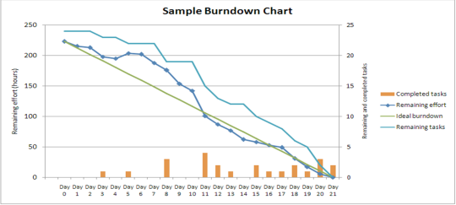**Burndown Chart**

| Purpose | a daily measure of work remaining in an iteration. |
| --- | --- |
| How is it updated? | Daily |
| How often is  it used? | Daily |
| Significance? | Shows a view of progress of the project in relation to Days left |

**User Stories**

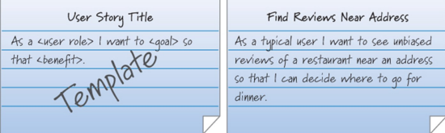

| Definition | Describes what user needs to do in the job function |
| --- | --- |
| Purpose | Explain, the “who,” “what,” and “why” of a requirement |
| Format | As a <user role> I want to <goal> so that <benefit>. |
| Source | Product owner |
| Attributes for completeness | * name * brief narrative * acceptance criteria * any defined conditions |

**Estimation**

| Story Points | Choosing enough work to fill up a full sprint:  Based on relative effort.  Show only the relative size of the item - not the time to complete.  Teams pick a simple, agreed-upon basis. |
| --- | --- |
| Planning Poker | Based on the Fibonacci Sequence:  Each numbered card represents the amount of work the team member believes this item represents.  Each development team member is issued one set of cards.  If when hands are shown, there is not a clear agreement on the amount of work involved, high and low bidders will explain why they chose that bid.  The team will re-vote until they reach a consensus. |
| Fibonacci  Sequence | The Fibonacci sequence is a type series where each number is the sum of the two that precede it. 1, 1, 2, 3, 5, 8, 13, 21, 34, 55 |